

**Week 9 Final Project Progress**

**Homepaw – Final Project Outline**

Name : Ahmad Zaydan

Student ID : 2702358393

Major : Computer Science

Course : Human & Computer Interaction

**Homepaw – Final Project Outline**



**Homepaw**

**A project by Code Cuts**

* Project Name: Homepaw
* Code Cuts member:

1. Ahmad Zaydan
2. Haniif Satria Wardana
3. Alvin Feriza

* General Statement

Lots of people at some point in their life need a pet or two. Companion animals such as pets can help people in many ways. It can mentally help them, it can accompany people who live alone, train responsibility, bring more liveliness to the household, and so on.

* Problem Analysis

We noticed that it’s not that easy for some people to get a pet nowadays. Some people don’t even know where to start. The most common ways for people to get a pet is either straightforwardly offered by someone, goes to an animal shelter or pet store, and meets up with a professional animal breeder. Sure, some people can take their time to go to this place, but for some people who are too busy or do not have those places nearby, it would be a problem.

* Solution

The solution we came up with is to make a web app so that people are able  to get a pet and to put their own pet for adoption. Introducing Homepaw, a web app that can do exactly that.

* Feature Goals

Can be accessed as easily as possible so that users are happy to choose our website. and maybe it's also famous so everyone is happy because it's not as difficult as other websites because our website offers different things from other websites out there.

* Persona

Name: Alex

Age: 26

Occupation: Doctor

Location: Canada

Lifestyle: Busy, Urban, Single

Short Biography:

Alex grew up in a small town but always dreamed of making it big in the bustling world of Canada. After earning his medical degree, he became a dedicated doctor working long hours at a renowned city hospital in Canada. His fast-paced lifestyle and demanding career have left him with little time for socializing, and he often feels lonely when he returns to his apartment in the city that never sleeps.

Frustrations:

* 1. Loneliness: Alex's busy work schedule and solitary living situation have left him feeling isolated and yearning for companionship.
  2. Time Constraints: His job often demands overtime and irregular hours, making it challenging to visit pet stores or shelters during their operational hours.
  3. Concerns About Responsibility: Alex is worried about his ability to provide proper care and attention to a pet, given his hectic lifestyle and small living space.

Goals:

* + Find Companionship: Alex's primary goal is to find a furry companion that can keep him company and help alleviate his loneliness.
  + Simplify Pet Adoption: He aims to adopt a pet through a simple and convenient process that accommodates his busy life.
  + Be a Responsible Pet Owner: Alex wants to educate himself about pet care and ensure that he can meet the responsibilities that come with owning a pet.

Motivation:

Alex is motivated by his desire for a happier and less lonely life. He believes that having a pet would bring joy and comfort to his home, helping him cope with the stresses of his medical career and the fast-paced urban life in Canada. Additionally, he recognizes that adopting a pet could also be a path to personal growth. It could help him become more responsible and learn to balance his demanding career with the needs of a furry companion. His motivation stems from the hope that he can create a nurturing and fulfilling environment for both himself and his future furry friend. Homepaw accessibility and resources provide him with the means to achieve this goal, motivating him to explore the world of pet ownership in a unique and convenient way.

* Information architecture

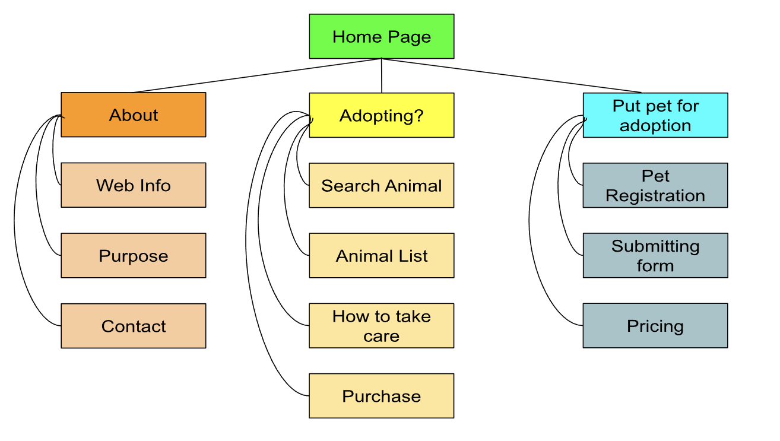

* Task Flow

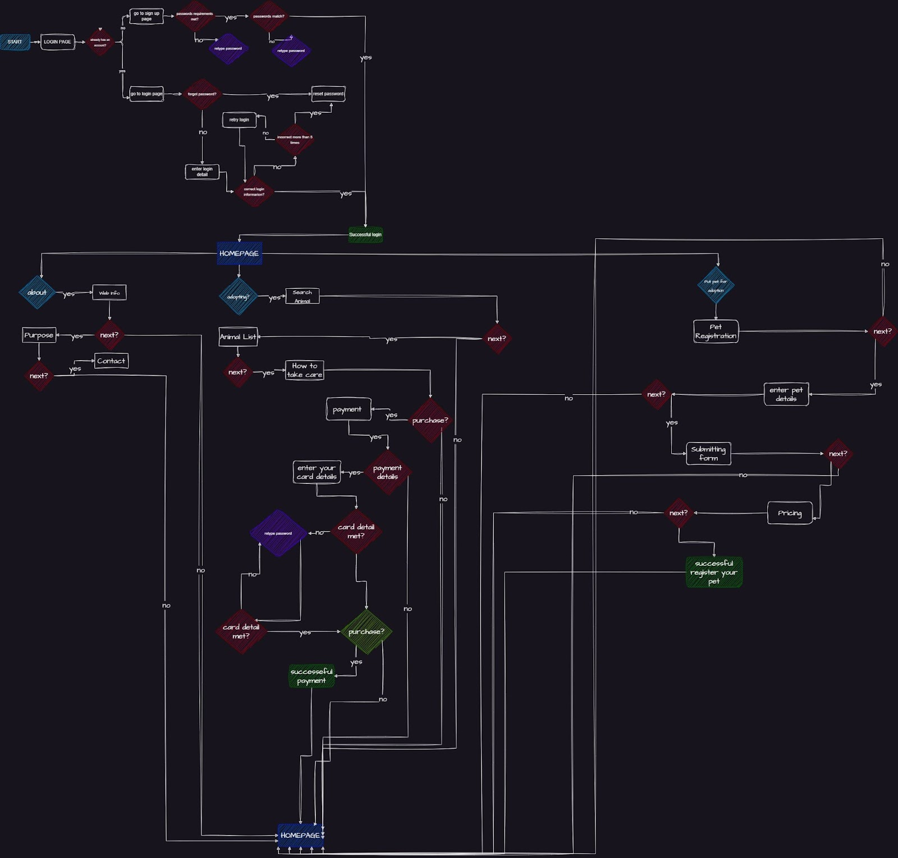

* Usecase

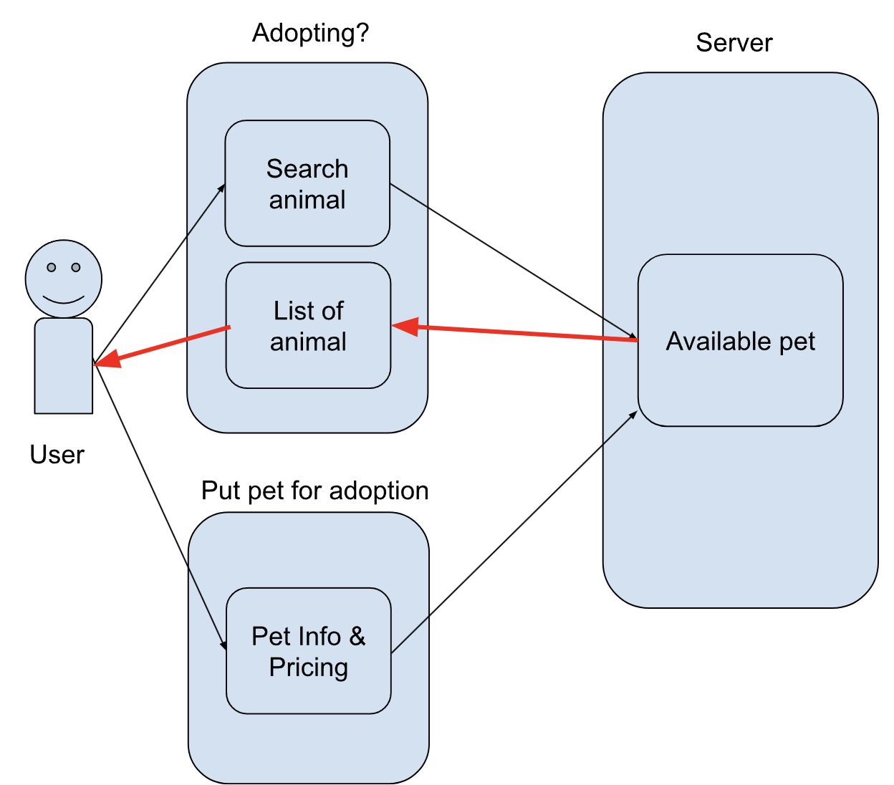

Registration Form